**CUSTOMER CARE REGISTRY**

[**SI-GuidedProject-53983-1663928165**](https://github.com/IBM-EPBL/SI-GuidedProject-53983-1663928165)

###### TEAM DETAILS:

***Team ID :*** *PNT2022TMID24347*

***College Name :*** *VELAMMAL INSTITUTE OF TECHNOLOGY*

***Department :*** *COMPUTER SCIENCE & ENGINEERING*

###### TEAM MEMBERS :

SANJAY S GOUTHAM K ROGITH M

SIVA SRIRAJ

***CONTENT***

1. ***INTRODUCTION***
   1. *Project Overview*
   2. *Purpose*
2. ***LITERATURE SURVEY***
   1. *Existing problem*
   2. *References*
   3. *Problem Statement Definition*
3. ***IDEATION & PROPOSED SOLUTION***
   1. *Empathy Map Canvas*
   2. *Ideation & Brainstorming*
   3. *Proposed Solution*
   4. *Problem Solution fit*
4. ***REQUIREMENT ANALYSIS***
   1. *Functional requirement*
   2. *Non-Functional requirements*
5. ***PROJECT DESIGN***
   1. *Data Flow Diagrams*
   2. *Solution & Technical Architecture*
   3. *User Stories*
6. ***PROJECT PLANNING & SCHEDULING***
   1. *Sprint Planning & Estimation*
   2. *Sprint Delivery Schedule*
   3. *Reports from JIRA*
7. ***CODING & SOLUTIONING (Explain the features added in the project along with code)*** *a.*

*Feature 1*

1. *Feature 2*
2. *Database Schema (if Applicable)*
3. ***TESTING***
   1. *Test Cases*
   2. *User Acceptance Testing*
4. ***RESULTS***
   1. *Performance Metrics*
5. ***ADVANTAGES & DISADVANTAGES***
6. ***CONCLUSION***
7. ***FUTURE SCOPE*** *13.* ***APPENDIX***
   1. *Source Code*
   2. *GitHub & Project Demo Link*

##### INTRODUCTION

***INTRODUCTION TO PROJECT***

* + 1. *The Customer Service Desk is a web*-*based project* *with Ibm_Db and Cloud Integration.*
    2. *Customer Service also known as Client Service is the provision of service to customers' Its significance varies by product, industry and domain. In many cases customer services is more important if the information relates to a service as opposed to a Customer.*
    3. *Customer Service may be provided by a Service Representatives Customer Service is normally an integral part of a company's customer value proposition.*

***PURPOSE OF THE PROJECT***

* + 1. *An online comprehensive Customer Care Solution is to manage customer interaction and complaints with the Service Providers over phone or through and e-mail. The system should have capability to integrate with any Service Provider from any domain or industry like Banking, Telecom Insurance. etc.*
    2. *Customer Service also known as Client Service is the provision of service to customers Its significance varies by product industry and domain. In many cases customer services is more important if the information relates to a service as opposed to as Customer*
    3. *Customer Service may be provided by a Service Representatives Customer Service is normally an integral part of a company's customer value proposition*

##### LITERATURE SURVEY

|  |  |  |  |  |
| --- | --- | --- | --- | --- |
| *S.NO & TITLE* | *PROPOSED WORK* | *TOOLS USED / ALGORITHMS* | *TECHNOLOGY* | *ADVANTAGES /DISADVANTAGES* |
| *REAL WORLD SMART CHATBOT FOR CUSTOMER CARE USING A*  *SOFTWARE AS A SERVICE (SAAS) ARCHITECTURE* | *This journal employ chatbot for customer care. This is done by*  *providing a human way interaction using LUIS and cognitive services.* | *AWS Public Cloud*   * *AWS Lambda* * *API Gateway* * *LUIS* * *14/11/2022Amarender KatkamEjabberd Chatbot* | * *Cloud Computing* * *Machine Learning* | *This proposes a robust, scalable, and extensible architecture with a technology*  *stack consisting of the EjabberdServer. The Ejabberd server makes creates the room functionality where the customer needs to be persistent over time in that room* |
| *AN INTELLIGENT CLOUD BASED CUSTOMER RELATIONSHIP MANAGEMENT SYSTEM TO DETERMINE FLEXIBLE PRICING FOR CUSTOMER RETENTION* | *This paper proposes that the customer are categorized based on purchase behaviours, historical ordering patterns and frequency of purchase customize customer care and promotions are given.* | * *Intelligent*   *Cloud based Customer Relationship*  *Management* | * *Cloud Computing*   *Artificial Intelligence* | *Customer care is given based upon purchase behaviours, features of the product purchased without any interaction.* |
| *CHATBOT FOR CUSTOMER SERVICE* | *In this paper customer trust chatbots to provide the required support.*  *Chatbots represent a potential means for automating customer service.* | * *Chatbot* * *Java Script* | * *Cloud Computing* * *Artificial Intelligence*   + *Machine Learning* | *This provides automated customer service with the use of the cloud.* |
| *ARTIFICIAL INTELLIGENCE REPLACING HUMAN CUSTOMER SERVICE* | *This journal Chatbots for customer care registry using Artificial intelligence. This assists consumers in decision making. Based on the computers-are-*  *social actors paradigm* | * *Chatbots* * *Python* * *Mongo DB* | * *Cloud Computing* * *Artificial Intelligence*   + *Machine Learning* | 1. *Maintain Flexibility and focus on their customers.* 2. *The use of chatbots in service interactions may raise greater consumer concerns regarding privacy risk issues.* |

|  |  |  |  |  |
| --- | --- | --- | --- | --- |
| *IMPLEMENTING CONTINUOUS CUSTOMER CARE* | *In this paper, we employ the software as a service (SaaS) model which introduces drastic improvement to the situation, as the service provider can now have direct access to the user data and analyse it if*  *agreed appropriately with the customer.* | * *Java Script*   + *HTML* * *Google Analytics* | * *Cloud Computing* * *Machine Learning* | *1. Feedback loops are used that allow the service provider to capture feedback at the point of experience. One way to find out is to*  *conduct continual end-user experience monitoring to determine if users are happy 2. It is not always easy for SaaS providers to know what customers are experiencing.*  *Literature survey* |

***EXISTING SYSTEM***

The existing system is a semi-automated at where the information is stored in the form of excel sheets in disk drives. The information sharing to the Volunteers, Group members, etc. is through mailing feature only. The information storage and maintenance is more critical in this system. Tracking the member's activities and progress of the work is a tedious job here. This system cannot provide the information sharing by 24x7 days.

### References

***1. help desk***

***2. live chat box support Problem***

***Statement Definition***

* A problem statement is a concise description of the problem or issues a project seeks to address.
* The problem statement identifies the current state, the desired future state and any gaps between the two.
* A problem statement is an important communication tool that can help ensure everyone working on a project knows what the problem they need to address is and assign agents

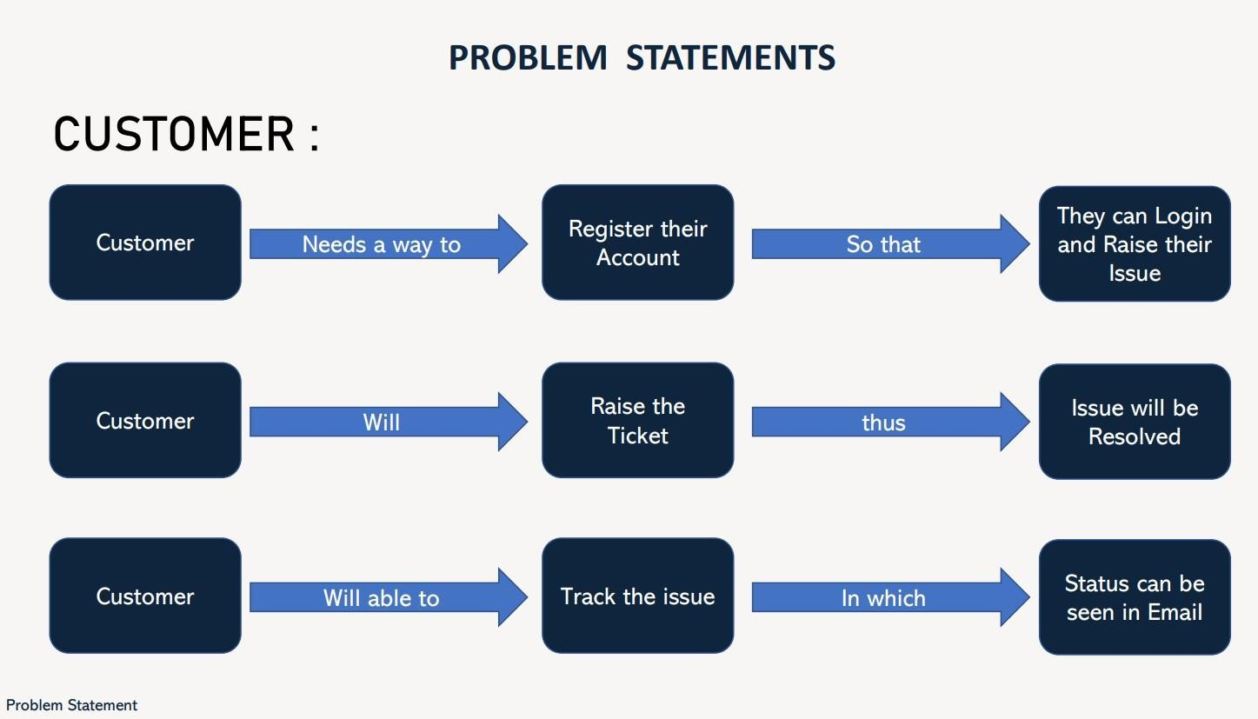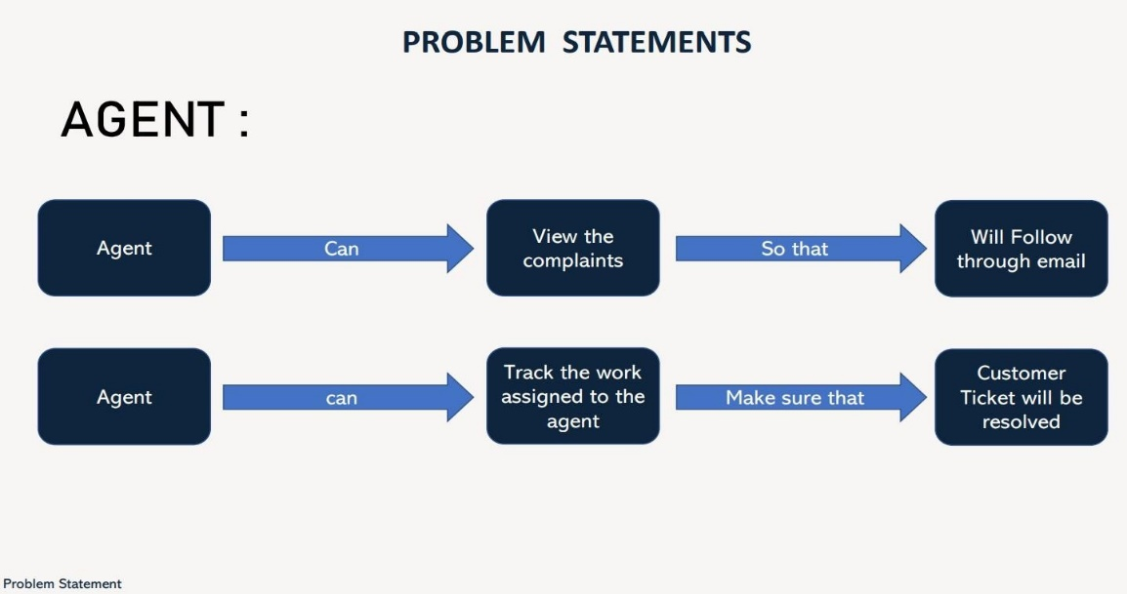

* ***ADMIN****: The main role and responsibility of the admin are to take care of the whole process. Starting from Admin login followed by the agent creation and assigning the customer's complaints. Finally, He will be able to track the work assigned to the agent and a notification will be sent to the customer.*
* ***USER*** *:They can register for an account. After the login, they can create the complaint with a description of the problem they are facing. Each user will be assigned with an agent. They can view the status of their complaint.*
* ***ADMIN****: After the user sucessfully Registered, their Admin has Quickly Respond to the user based on their grievances.*

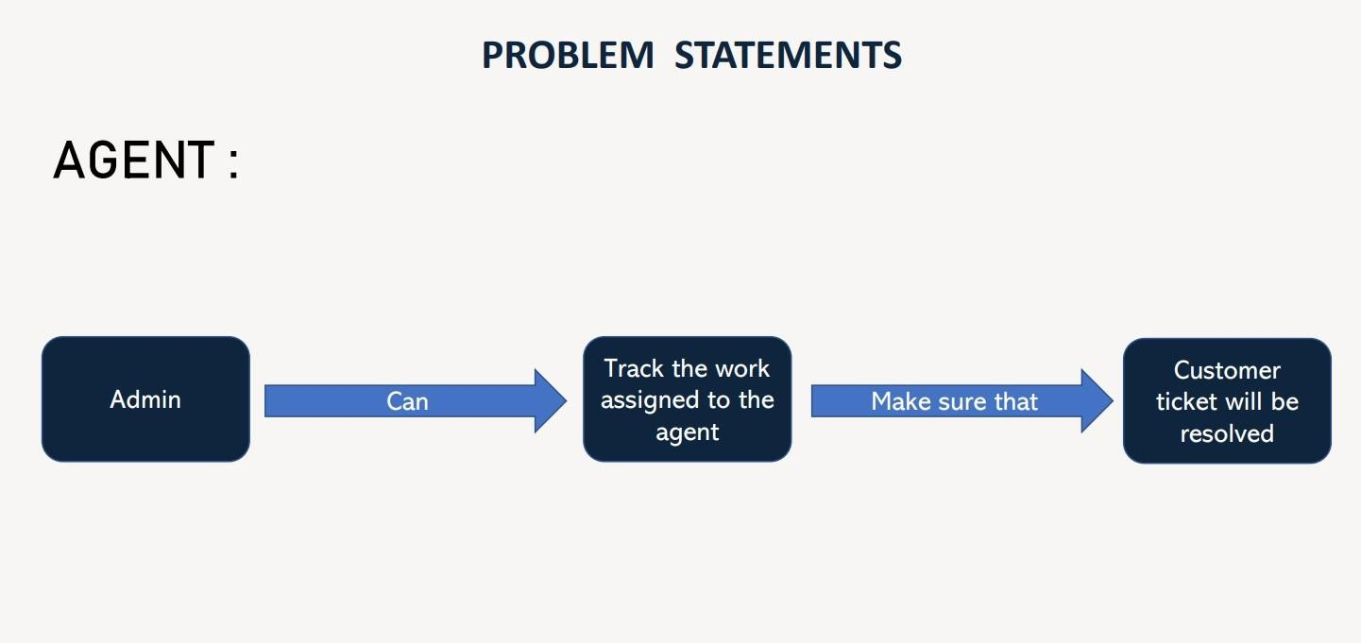

### 3.IDEATION & PROPOSED SOLUTION

##### Empathy Map Canvas

*An empathy map is* ***a collaborative tool teams can use to gain a deeper insight into their customers****. Much like a user persona, an empathy map can represent a group of users, such as a customer segment. The empathy map was originally created by Dave Gray and has gained much popularity within the agile community.*

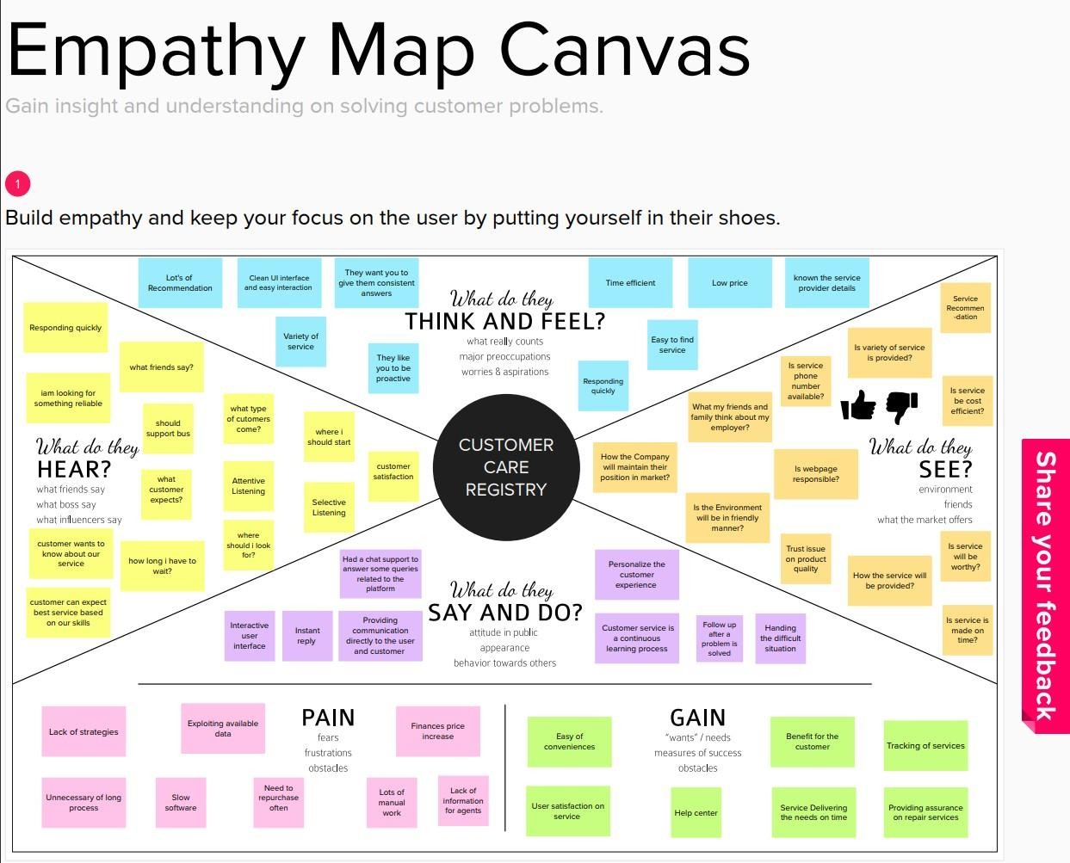

### Ideation & Brainstorming

* + - Ideation and the practise of brainstorming, a particular method for coming up with fresh ideas, are frequently closely related. The main distinction between ideation and brainstorming is that whereas brainstorming is nearly often done in groups, ideation is typically seen as being more of a solitary endeavour. A group of people are frequently gathered for a brainstorming session to generate either fresh, general ideas or solutions to specific problems or circumstances.
    - On instance, a large firm that has discovered it is the target of a significant lawsuit might wish to consult with its top executives to come up with ideas for how to publicly respond to the case being filed.
    - In a brainstorming session, participants are encouraged to freely share any ideas that may come to mind. According to the theory, by coming up with a lot of ideas, the brainstorming group is more likely to find a workable solution to the problem they are trying to solve.
    - With the creation of various brainstorming software tools, such Brightidea and Idea wake, the distinction between ideation and brainstorming has gotten a little bit more hazy. The applications frequently mix the ideation and brainstorming processes in that they can be used by individual employees, but businesses can replicate brainstorming sessions by having multiple employees use the software to produce fresh ideas for a problem.

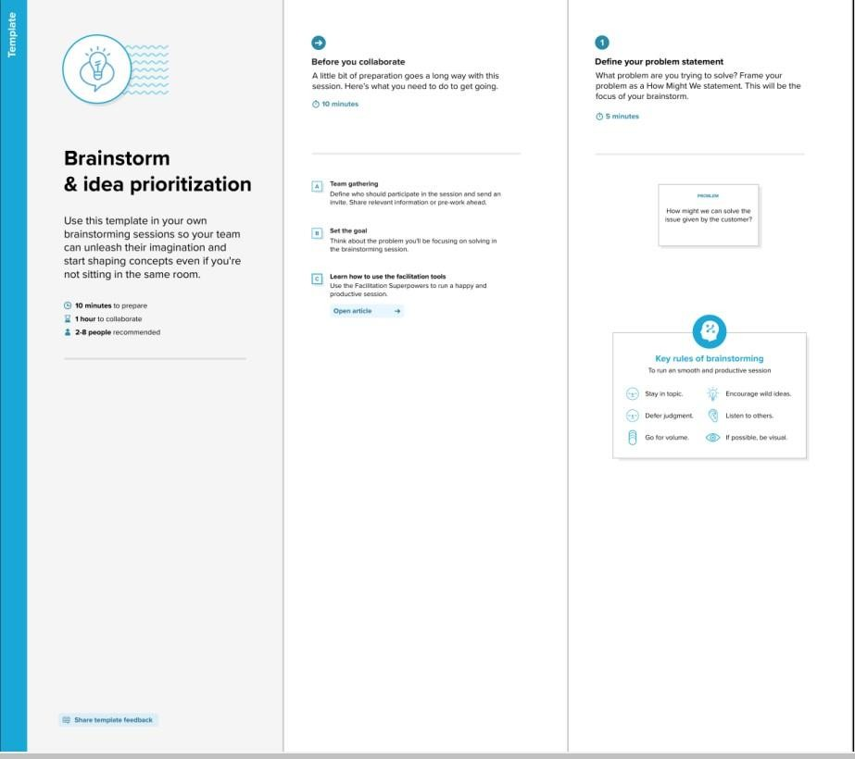

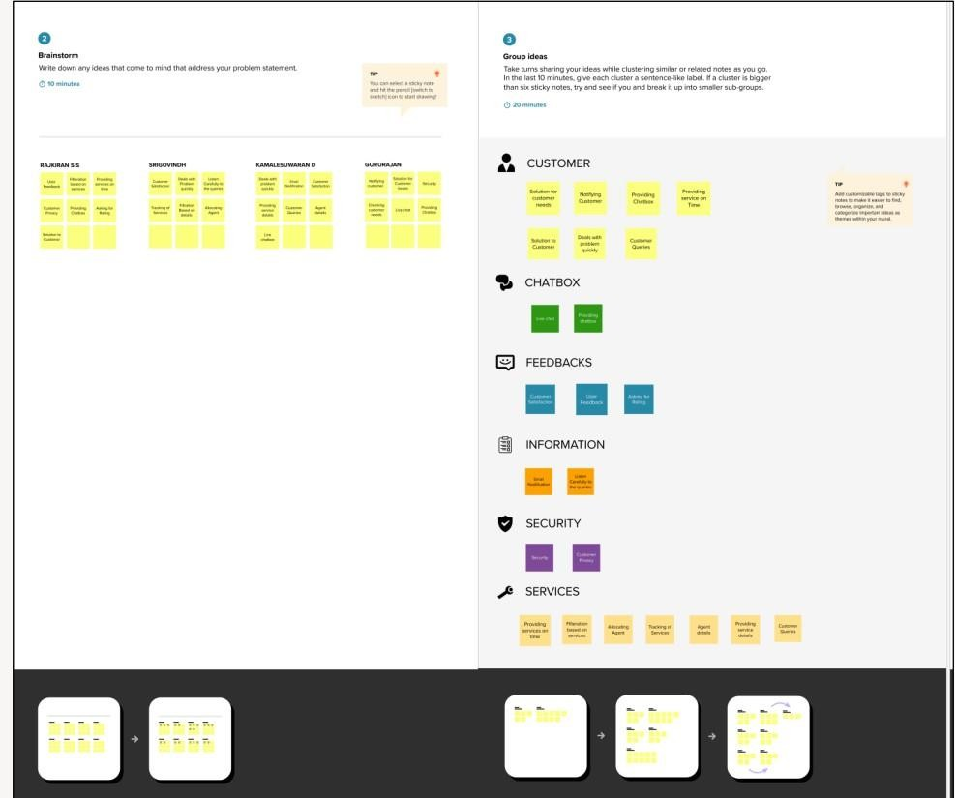

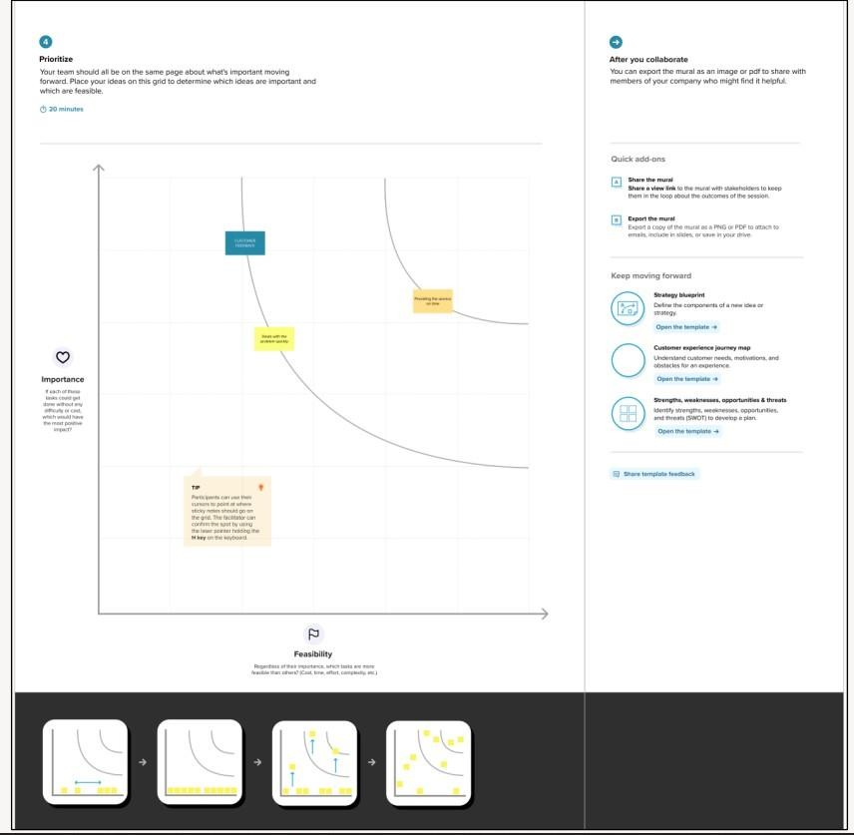

### Proposed Solution

|  |  |  |
| --- | --- | --- |
| *S.NO.* | *PARAMETER* | *DESCRIPTION* |
| ***01*** | *Problem Statement (Problem to be solved)* | *To solve customer issues using Cloud Application*  *Development.* |
| ***02*** | *Idea / Solution description* | *Assigned Agent routing can be solved by directly routing to the specific agent about the issue using the specific Email. Automated Ticket closure by using daily sync of the daily database. Status Shown to the Customer can display the status of the ticket to the customer. Regular data retrieval*  *in the form of retrieving lost data.* |
| ***03*** | *Idea / Solution description* | *Assigned Agent Routing, Automated Ticket Closure, Status Shown to the Customer, and Backup data in case of failures.* |
| ***04*** | *Social Impact / Customer Satisfaction* | *Customer Satisfaction, Customer can track their status and Easy agent communication.* |
| ***05*** | *Business Model (Revenue Model)* | * *Key Partners are Third-party applications, agents, and customers.* * *Activities held as Customer Service, System Maintenance.* * *Key Resources support Engineers, Multi-channel.* * *Customer Relationship have 24/7 Email Support, Knowledge-based channel.* * *Cost Structure expresses Cloud Platform, Offices* |
| ***06*** | *Scalability of the Solution* | *The real goal of scaling customer service is providing an environment that will allow your customer service specialists to be as efficient as possible. An environment where they will be able to spend less time on grunt work and more time on actually resolving critical customer*  *issues* |

***Problem Solution fit***

1. *Problem-Solution Fit - this occurs when you have evidence that customers care about certain jobs, pains, and gains. At this stage you've proved the existence of a problem and have designed a value proposition that addresses your customers' jobs, pains and gains. Unfortunately you still do not have clear evidence that your customer really care enough about your value proposition enough to buy it.*

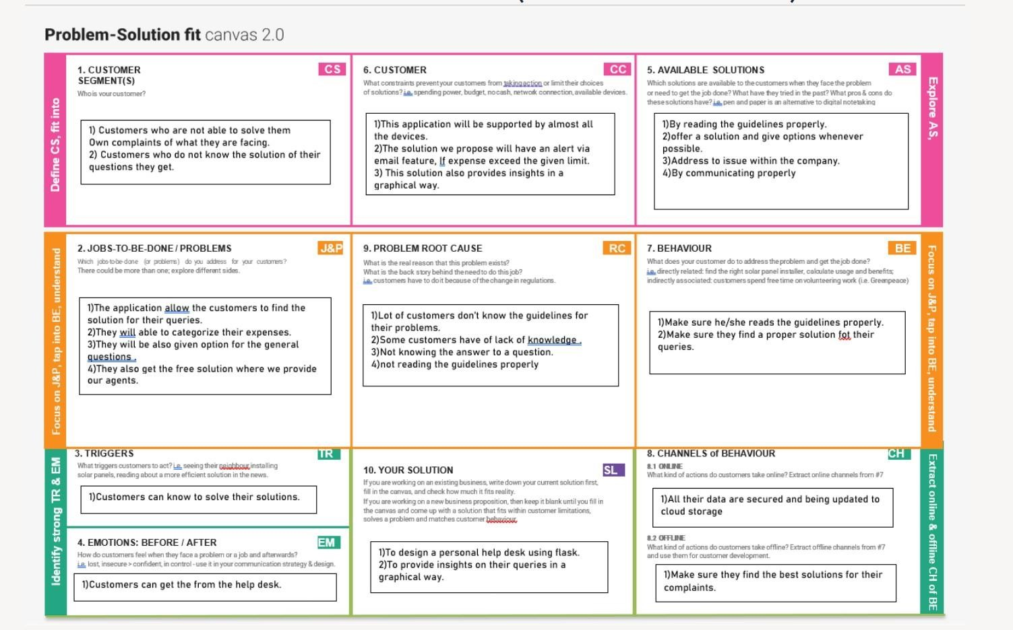

### REQUIREMENT ANALYSIS

What is Requirement Analysis: It is the process of determining user expectations for a system under consideration.

These should be quantifiable and detailed. Requirement Analysis:

➤ Serves as a foundation for test plans and project plan

➤ Serves as an agreement between developer and customer

➤ Process to make stated and unstated requirements clear

➤ Process to validate requirement for completeness, ambiguity and feasibility.

###### Functional requirement

Functional requirements specify what a system should be able to do through computations, technical details, data manipulation and processing, and other specialised functions. Use cases, which are used to represent behavioural requirements, explain all the instances in which the system makes use of the functional requirements. Non-functional requirements, commonly referred to as "quality requirements," which place restrictions on the design or execution, support functional requirements (such as performance requirements, security, or reliability). Non-functional requirements often take the form "system shall be," while functional needs are typically articulated in the form "system must do."

While non-functional needs are defined in the system architecture, the plan for accomplishing functional requirements is detailed in the system design.

Functional requirements, as used in requirements engineering, outline specified outcomes of a system.

*****Functional requirements*** *are product features or functions that developers must implement to enable users to accomplish their tasks. So, it’s important to make them clear both for the development team and the stakeholders. Generally, functional requirements describe system behaviour under specific conditions. For example:*

The system sends an approval request after the user enters personal information.

A search feature allows a user to hunt among various invoices if they want to credit an issued invoice.

The system sends a confirmation email when a new user account is created.

### Non-functional requirements

In general, non-functional requirements outline what a system is supposed to be rather than what it should be able to perform. Functional requirements are typically expressed as "system shall do," an individual action or component of the system, maybe explicitly in terms of a mathematical function, or as a black box description of an input, output, process, and control functional model, also known as an IPO Model. Non-functional requirements, on the other hand, have the form of "system shall be," which refers to a general characteristic of the system as a whole or of a particular aspect rather than a specific function. The overall characteristics of the system frequently determine whether a development project is a success or a failure.

Non-functional requirements are frequently referred to as a product's "quality traits" in error.

*Non-functional* ***requirements,*** *not related to the system functionality, rather define how the system should perform. Some examples are: The website pages should load in 3 seconds with the total number of simultaneous users <5 thousand.*

* The system should be able to handle 20 million users without performance deterioration.  Here’s a brief comparison and then we’ll proceed to a more in-depth explanation of each group.*

### PROJECT DESIGN

***Data Flow Diagrams***

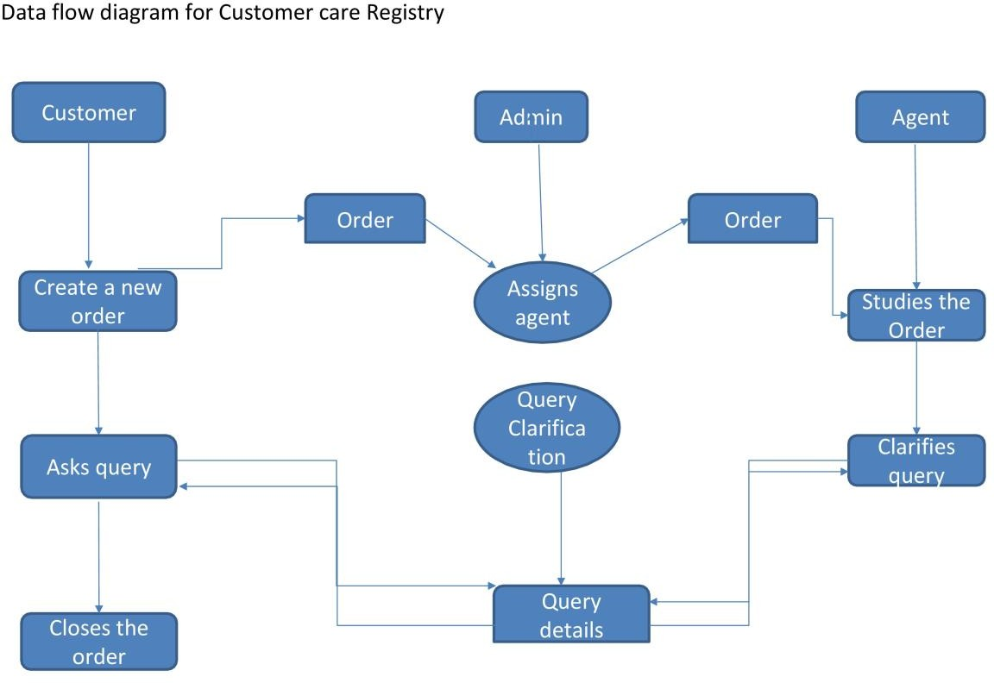

***Solution & Technical Architecture***

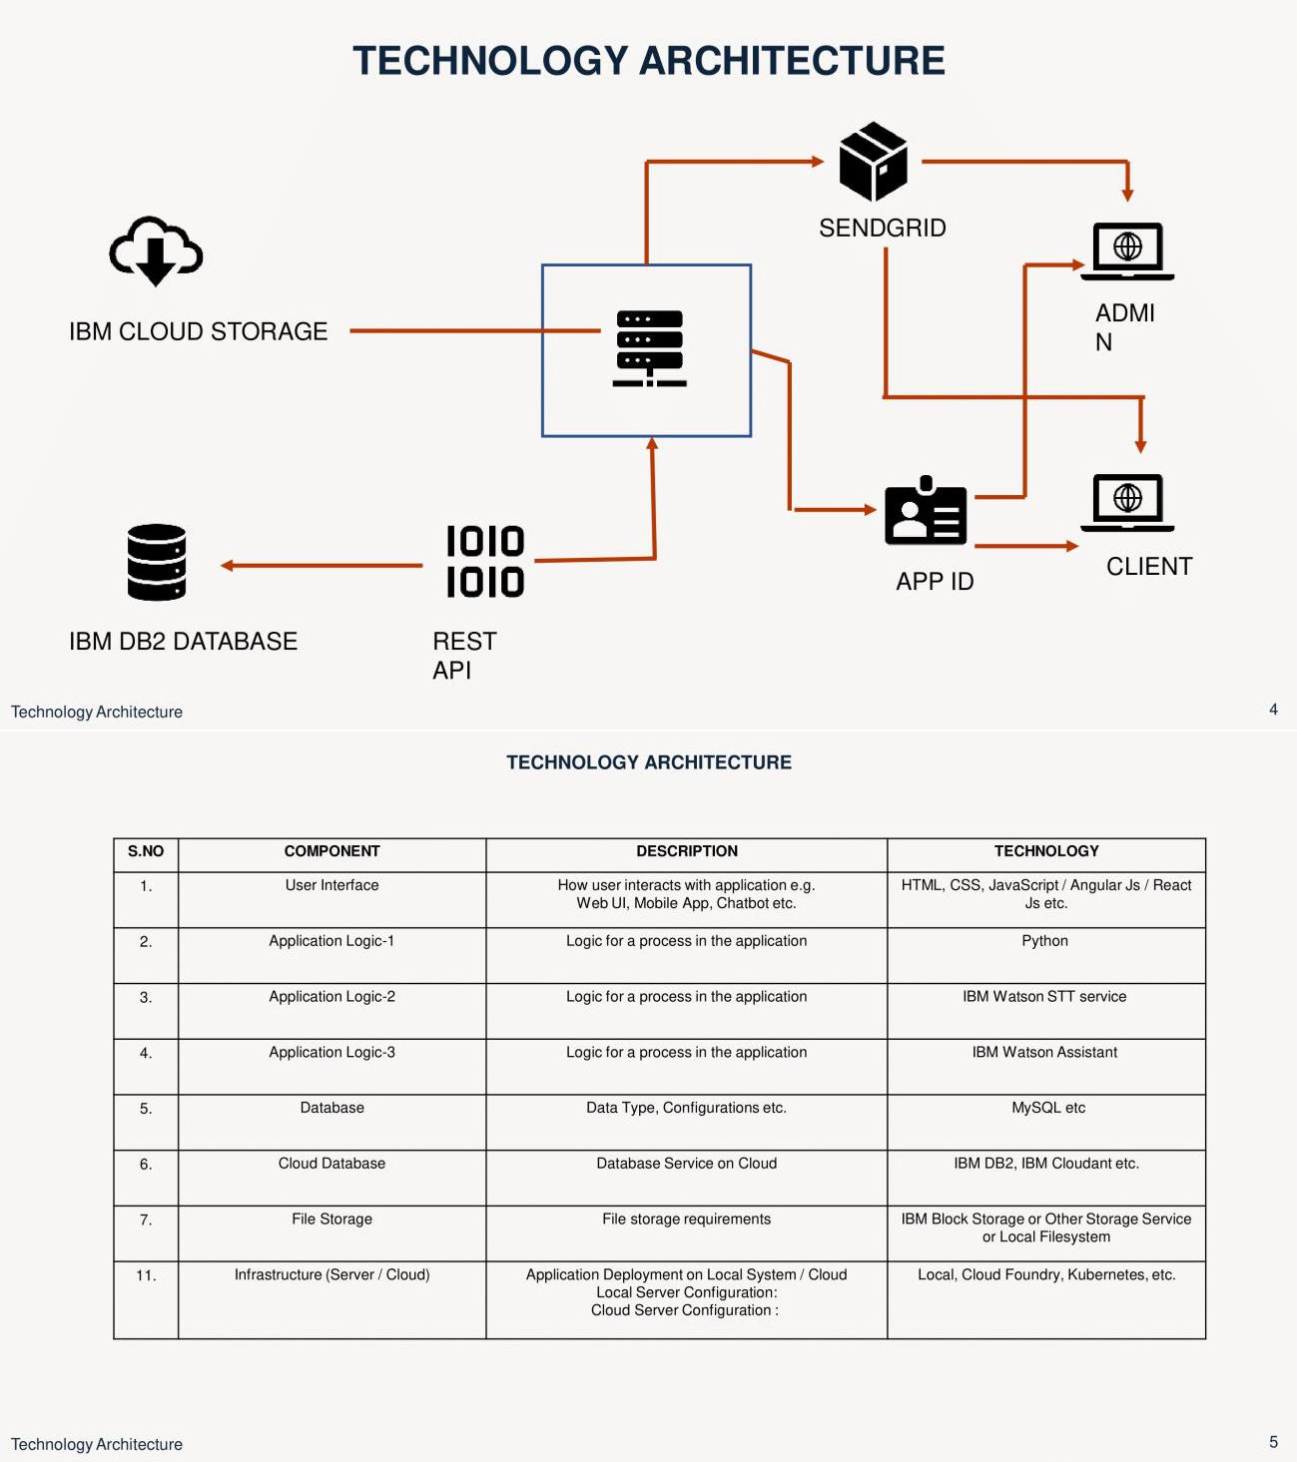

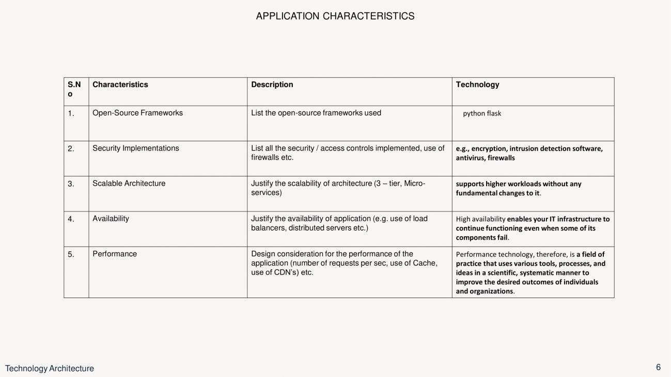

### USER STORIES

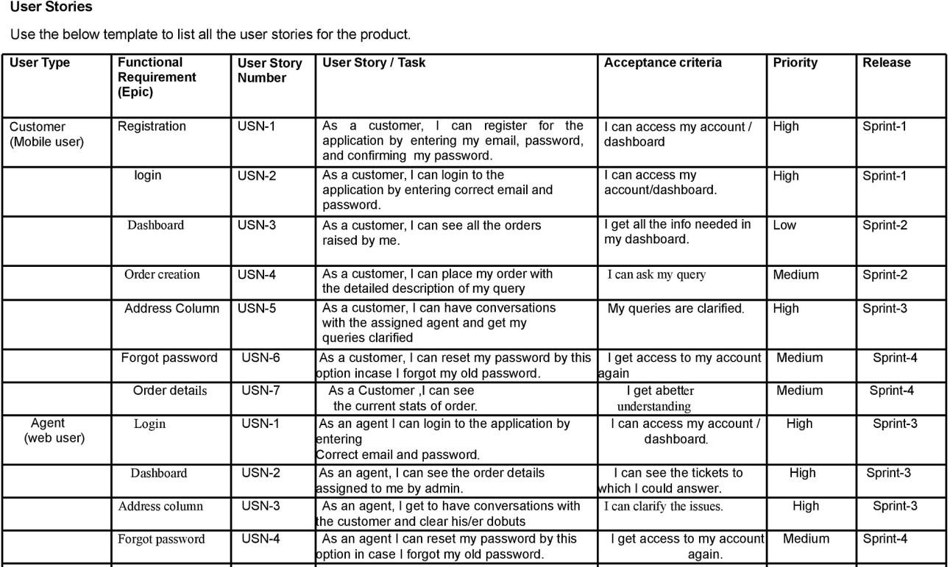

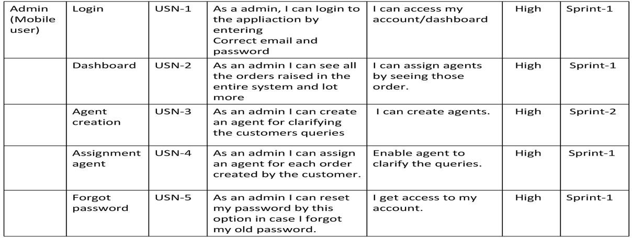

* 1. ***PROJECT PLANNING & SCHEDULING***

*‘Project Planning and Scheduling’, though separate, are two sides of the same coin in project management. Fundamentally, ‘Project planning’ is all about choosing and designing effective policies and methodologies to attain project objectives. While*

*‘Project scheduling’ is a procedure of assigning tasks to get them completed by*

*allocating appropriate resources within an estimated budget and time-frame.*

*The basis of project planning is the entire project. Unlikely, project scheduling focuses only on the project-related tasks, the project start/end dates and project dependencies. Thus, a ‘project plan’ is a comprehensive document that contains the project aims, scope, costing, risks, and schedule. And a project schedule includes the estimated dates and sequential project tasks to be executed.*

###### Project Planning

The project planning phase refers to:

* *Developing a project to make it ready for investment*
* *Determines the jobs/tasks required to attain project objectives*

### Sprint Planning & Estimation

##### What is sprint planning?

 Sprint planning is an event in scrum that kicks off the sprint.

 The purpose of sprint planning is to define what can be delivered in the sprint and how that work will be achieved.

 Sprint planning is done in collaboration with the whole scrum team.

* In scrum, the sprint is a set period of time where all the work is done.  However, before you can leap into action you have to set up the sprint.*

* You need to decide on how long the time box is going to be, the sprint goal,*

*and where you're going to start.*

 The sprint planning session kicks off the sprint by setting the agenda and focus. If done correctly, it also creates an environment where the team is motivated, challenged, and can be successful.

 Bad sprint plans can derail the team by setting unrealistic expectations.

*Sprint 1*

HOMEPAGE

LOGIN PAGE(CUSTOMER) ADMIN PAGE(CUSTOMER_LIST) AGENT LOGIN PAGE

#### HOMEPAGE :

Verify user is able to see the Login/Signup pop-up when user clicked on My account button Steps To Execute : 1.Enter URL and click go

1. *Scroll down*
2. *Verify login/Singup pop-up displayed or not*

Actual Result : Working as expected status : PASS

#### LOGIN PAGE(CUSTOMER) :

Verify user is able to see the User home page when user finish on submitting Credentials

Steps To Execute :

1.Enter URL(http:// 169.51.206.150:32144/) and click go

2. To the User Login page and submit Your Credentials Actual Result : USER Home Page pop-up should display status : PASS

ADMIN PAGE(CUSTOMER_LIST)

Verify user is able to see the ADMIN home page when user finish on submitting Credentials

Steps To Execute :

1.Enter URL(http:// 169.51.206.150:32144/) and click go

2. To the User Login page and submit Your Credentials Actual Result : ADMIN Home Page pop-up should display status : PASS

AGENT LOGIN PAGE :

On delete Button the user Credentials will be delected Steps To Execute :

1.Enter URL(http://169.51.206.150:32144/) and click go

2. To the User Login page and submit Your Credentials Actual Result :

ADMIN Home Page pop-up should display Acceptance Testing status

: PASS

### Sprint 2

HOMEPAGE AGENT HOMEPAGE

CUSTOMER HOMEPAGE ADMIN (AGENT LIST) WEBCHAT

#### HOMEPAGE :

Verify user is able to see the Login/Signup pop-up when user clicked on My account button Steps To Execute : 1.Enter URL and click go

2.Scroll down 3.Verify login/Singup pop-up displayed or not Actual Result : Working as expected status

: PASS

AGENT LOGIN PAGE :

On delete Button the user Credentials will be delected Steps To Execute :

1.Enter URL(http:// 169.51.206.150:32144/) and click go

2. To the User Login page and submit Your Credentials Actual Result :

ADMIN Home Page pop-up should display Acceptance Testing status

: PASS

#### LOGIN PAGE(CUSTOMER) :

Verify the User has No Complaint Steps To Execute :

1.Enter URL(http:// 169.51.206.150:32144/) and click go

2. To the User Login page and submit Your Credentials Actual Result :No Complaint should shown status : PASS

ADMIN PAGE(CUSTOMER_LIST)

Verify the overall Delect the database for User Steps To Execute :

1.Enter URL(http:// 169.51.206.150:32144/) and click go

2. To the User Login page and submit Your Credentials

Actual Result : Delect the overall Agent database delect status : PASS

#### WEBCHAT

A chatbot is a support system for your customer service. Using artificial intelligence and natural language processing, your chatbot can simulate conversation with a user through messaging applications, websites, mobile apps and more, giving them accurate and relevant information. By powering your AI chatbot with Watson Assistant, you can avoid the difficulties associated with traditional chatbot building platforms and build a tool that will improve your customer support.

### Sprint 3

HOMEPAGE

CUSTOMER COMPLAINT_PAGE CUSTOMER HOMEPAGE

ADMIN PAGE(COMPLAINT_LIST) AGENT ALLOTMENT

#### HOMEPAGE :

Verify user is able to see the Login/Signup pop-up when user clicked on My account button Steps To Execute : 1.Enter URL and click go

1. *Scroll down*
2. *Verify login/Singup pop-up displayed or not*

Actual Result : Working as expected status : PASS

CUSTOMER COMPLAINT_PAGE

Verify user is able to see the User home page when user finish on submitting Credentials

Steps To Execute :

1.Enter URL(http:// 169.51.206.150:32144/) and click go

2. To the User Login page and submit Your Credentials Actual Result : USER Home Page pop-up should display status : PASS

ADMIN PAGE(CUSTOMER_LIST)

Verify user is able to see the ADMIN home page when user finish on submitting Credentials

Steps To Execute :

1.Enter URL(http:// 169.51.206.150:32144/) and click go

2. To the User Login pageand submit Your Credentials Actual Result : ADMIN Home Page pop-up should display status : PASS

AGENT LOGIN PAGE :

On delete Button the user Credentials will be delected Steps To Execute :

1.Enter URL(http:// 169.51.206.150:32144/) and click go

2. To the User Login page and submit Your Credentials Actual Result :

ADMIN Home Page pop-up should display Acceptance Testing status

: PASS

### Sprint 4

Testing the user and Admin login page Testing the sign in and sign up

Testing the all page status : PASS

*Reports from JIRA :*

Jira's value proposition heavily relies on its reporting capabilities. By delivering critical insights in real time, reporting elevates the value of your Jira deployment and empowers your team to take informed decisions that improve output and performance. It is crucial to evaluate each project's status in order to accomplish objectives and control workloads. Jira reports can aid teams in quickly identifying and resolving performance, bandwidth, and workflow obstacles, enabling them to stay on top of both short-term and long-term projects.

It's crucial to note that Jira provides a variety of tools and reports to assist you in getting a clear picture of your team's progress, each with unique advantages, restrictions, and applications. Each team or organisation should utilise the reports and resources that

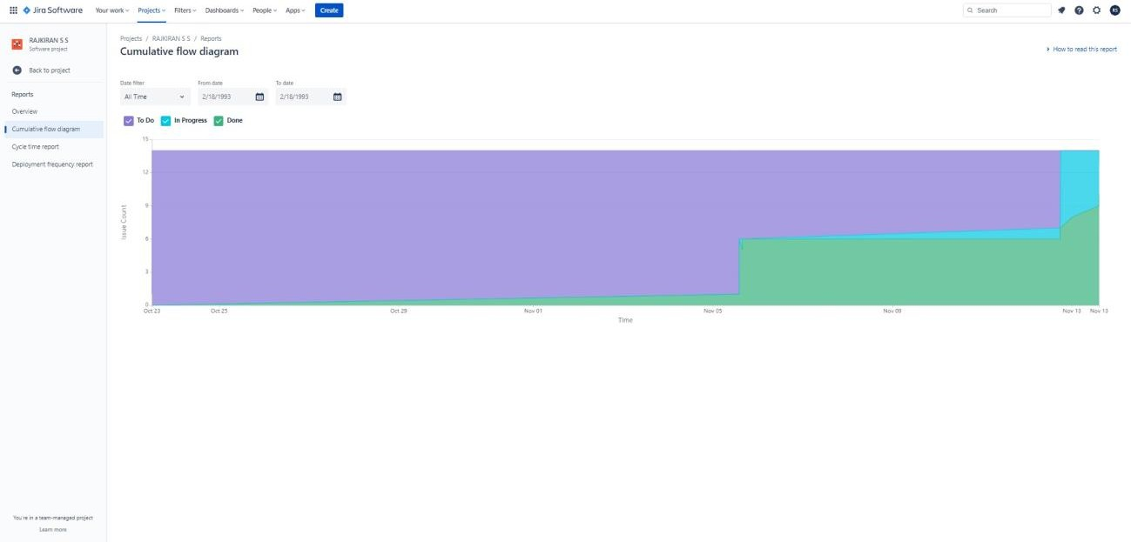

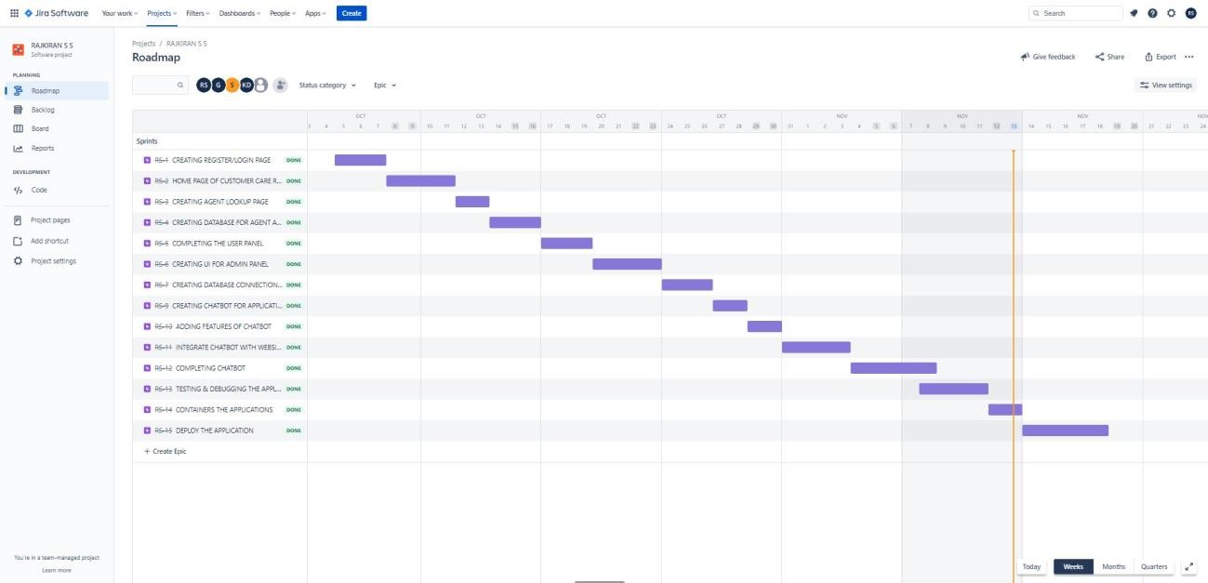

*7.CODING & SOLUTIONING*

College graduates with prior programming expertise or technical degrees are recruited and transitioned into professional positions with Alabama firms and

organisations through the highly competitive CodingSolutions job accelerator and talent refinement programme at no cost to the graduates. We provide a pool of varied, well-trained, techs-savvy individuals that wants to launch and advance their career in Alabama.

The mission of veteran- and woman-owned CodingSolutions is to mobilise the next generation of IT talent and provide them the tools and resources they require to make your business successful. Innovative talent is necessary for innovative technologies. We wish to provide CodingSolutions prospects to assist you expand your Alabama team.

Our applicants are swiftly hired at the top of the list by growing businesses for lucrative, long-term positions.

*Features*

*7 main types of customer needs :*

* Friendliness Empathy*

* Fairness Control*

* Alternatives Information Time*

### Friendliness

*This is the most basic customer need that’s associated with things like courtesy and politeness. Friendly agents are a top indicator of a good customer experience, according to the customers surveyed in our 2021 Trends Report.*

### Empathy

*Customers need to know the organization understands and appreciates their needs and circumstances. In fact, 49% surveyed in our* [*2021 Trends Report*](https://www.zendesk.com/customer-experience-trends/) *said they want agents to be empathetic.*

### Fairness

*Customers must feel that they’re getting adequate attention and fair and reasonable answers.*

### Control

*Customers want to feel like they have an influence on the outcome. You can empower your customers by listening to their feedback and using it to improve.*

### Alternatives

*Customers want choice and flexibility from customer service; they want to know there is a range of options available to satisfy them. In fact, high-performing companies are more likely to provide customers with a choice of customer service channels. 50% of high performers have adopted an omnichannel support strategy, compared to 18% of their lower-performing peers.*

## *Information*

*Customers want to know about products and services in a pertinent and time-sensitive manner; too much information and selling can be off-putting for them. A knowledge base is a great way to provide existing customers with the information they need, when they need it. And highperforming CX teams are more likely to offer a knowledge base, according to our research.*

## *Time*

*Customers’ time is valuable, and organizations need to treat it as such. 73% of customers said resolving their issues quickly is the top component of a good customer experience. To deliver on that expectation, CX teams need* [*customer service software*](https://www.zendesk.com/service/ticketing-system/customer-service-management-software/) *that arms them with tools to respond to customers quickly and effectively.*

#### Database Schema :

A database schema defines how data is organized within a relational database; this is inclusive of logical constraints such as, table names, fields, data types, and the relationships between these entities. Schemas commonly use visual representations to communicate the architecture of the database, becoming the foundation for an organization’s data management discipline. This process of database schema design is also known as data modeling.

These data models serve a variety of roles, such as database users, database administrators, and programmers. For example, it can help database administrators manage normalization processes to avoid data duplication.

Alternatively, it can enable analysts to navigate these data structures to conduct reporting or other valuable business analyses. These diagrams act as valuable documentation within the database management system (DBMS), ensuring alignment across various stakeholders.

# Types of database schemas

Database schema types

 Although the term "schema" is used in a wide variety of contexts, it most frequently refers to three distinct types of schema: conceptual database schemas, logical database schemas, and physical database schemas.

 Conceptual schemas provide a broad overview of the system's contents, organisational structure, and business rules. Typically, conceptual models are developed as a part of obtaining the initial project requirements.

 Comparatively speaking, logical database schemas are less abstract than conceptual schemas. Table names, field names, entity relationships, and integrity constraints—i.e., any regulations governing the database—are all well defined schema objects with information. They normally don't have any technical requirements, though.

The technical details that the logical database schema lacks are provided by physical database schemas.

### TESTING :

***Test cases :***

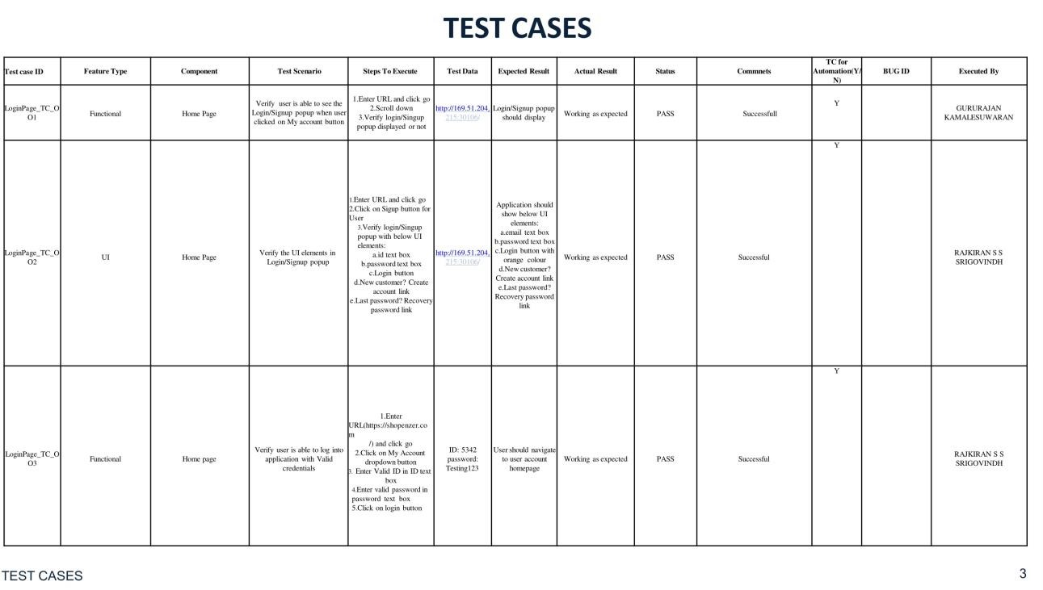

VENKATRAJ R ARUNACHALAM M

YASHWANTHRAJ J S

VENKATRAJ R

ARUNACHALAM M

ASWIN KUMAR R

YASHWANTHRAJ J S

VENKATRAJ R

ARUNACHALAM M

VENKATRAJ R

ASWIN KUMAR R

VENKATRAJ R

*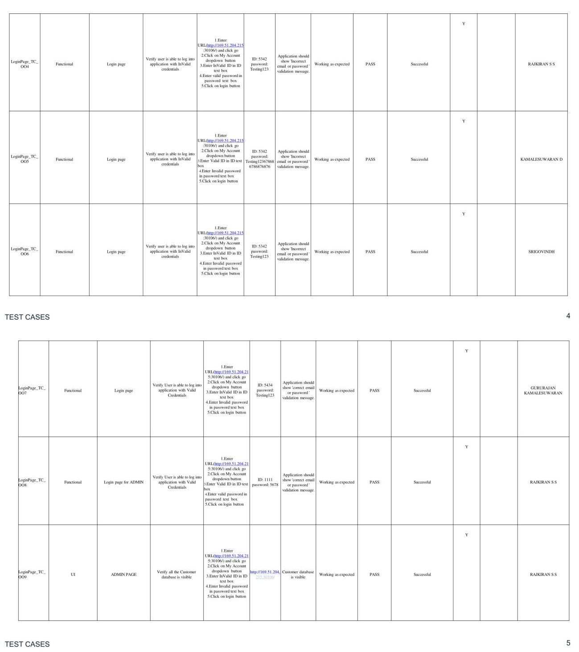VENKATRAJ R*

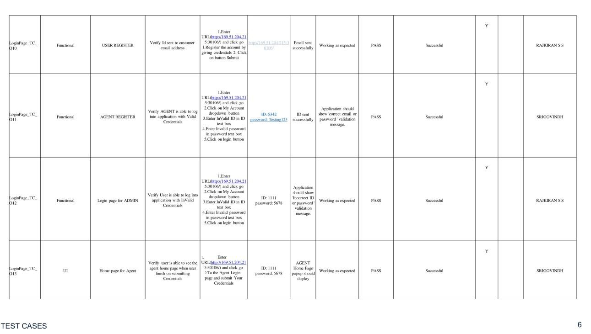

YASHWANTHRAJ J S

YASHWANTHRAJ J S

ASWIN KUMAR R

ARUNACHALAM M

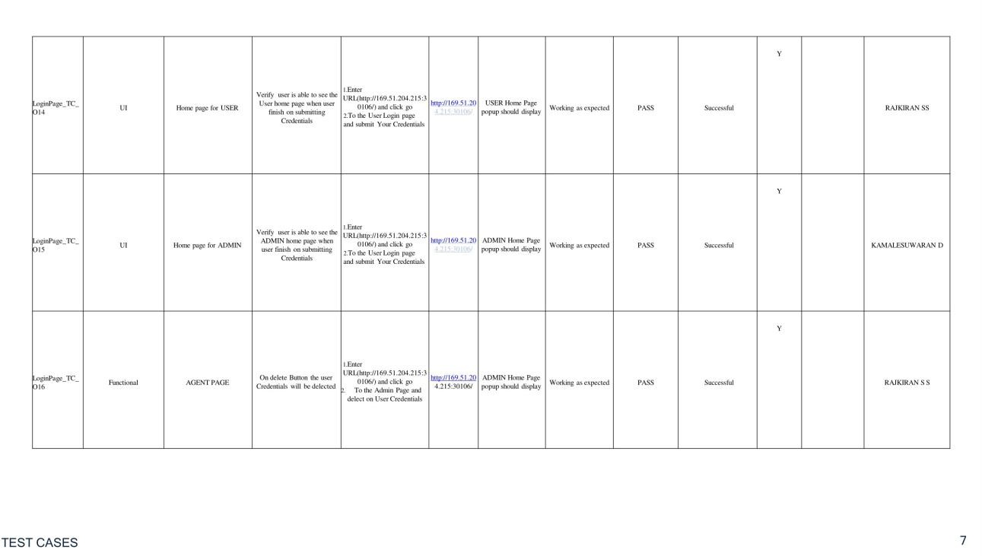

ASWIN KUMAR R

VENKATRAJ R

YASHWANTHRAJ J S

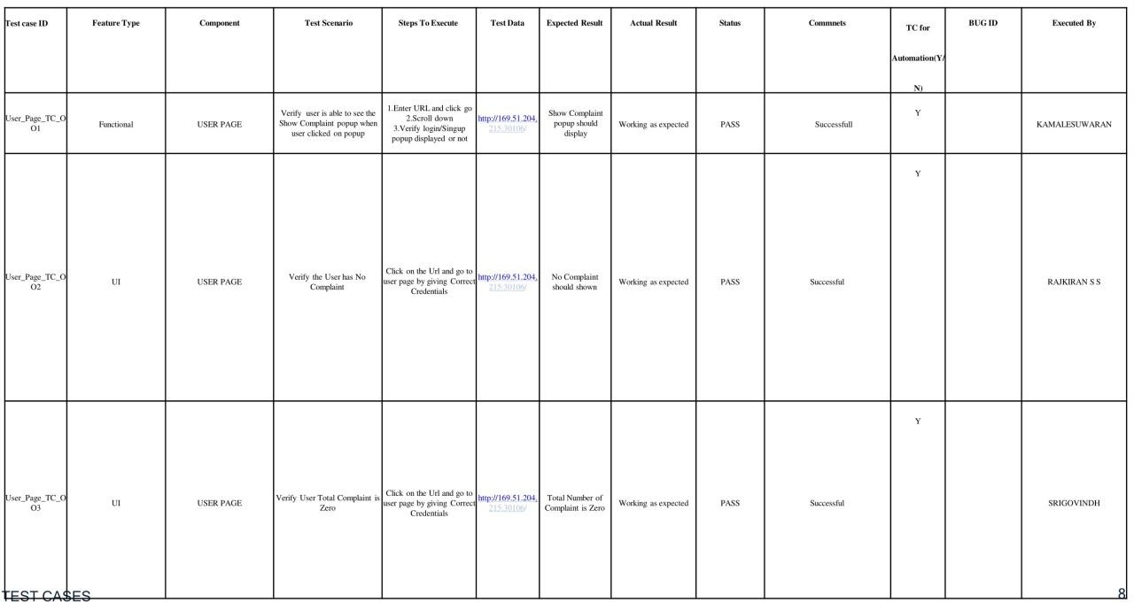

VENKATRAJ R

ARUNACHALAM M

ASWIN KUMAR R

***Acceptance Testing***

***UAT Execution & Report Submission***

###### Purpose of Document

*The purpose of this document is to briefly explain the test coverage and open issues of the [Customer Care Registry] project at the time of the release to User Acceptance Testing (UAT).*

###### Defect Analysis

*This reportshows the numberof resolved or closed bugs at each severity level,and how they were resolved*

|  |  |  |  |  |  |
| --- | --- | --- | --- | --- | --- |
| ***Resolution*** | ***Severity 1*** | ***Severity 2*** | ***Severity 3*** | ***Severity 4*** | ***Subtotal*** |
| *By Design* | *10* | *4* | *5* | *5* | *24* |
| *Duplicate* | *2* | *0* | *2* | *0* | *4* |
| *External* | *5* | *3* | *2* | *1* | *11* |

|  |  |  |  |  |  |
| --- | --- | --- | --- | --- | --- |
| *Fixed* | *15* | *5* | *5* | *10* | *35* |
| *Not Reproduced* | *0* | *0* | *0* | *0* | *0* |
| *Skipped* | *0* | *0* | *1* | *1* | *2* |
| *Won't Fix* | *0* | *5* | *2* | *1* | *8* |
| *Totals* | *32* | *17* | *17* | *18* | *84* |

* 1. ***Test Case Analysis***

*This report shows the number of test cases that have passed, failed,and untested*

|  |  |  |  |  |
| --- | --- | --- | --- | --- |
| ***Section*** | ***Total Cases*** | ***Not Tested*** | ***Fail*** | ***Pass*** |
| *Print Engine* | *10* | *0* | *0* | *10* |
| *Client Application* | *40* | *0* | *0* | *40* |
| *Security* | *5* | *0* | *0* | *2* |

|  |  |  |  |  |
| --- | --- | --- | --- | --- |
| *Outsource Shipping* | *3* | *0* | *0* | *3* |
| *Exception Reporting* | *10* | *0* | *0* | *10* |
| *Final Report Output* | *4* | *0* | *0* | *4* |
| *Version Control* | *4* | *0* | *0* | *4* |

* + 1. ***RESULTS :***

*What Are Performance*

*Metrics*

*Performance metrics are data used to track processes within a business. This is achieved using activities, employee behavior, and productivity as key metrics. These metrics are then used by employers to evaluate performance.*

*This is in relation to an established goal such as employee productivity or sales objective*

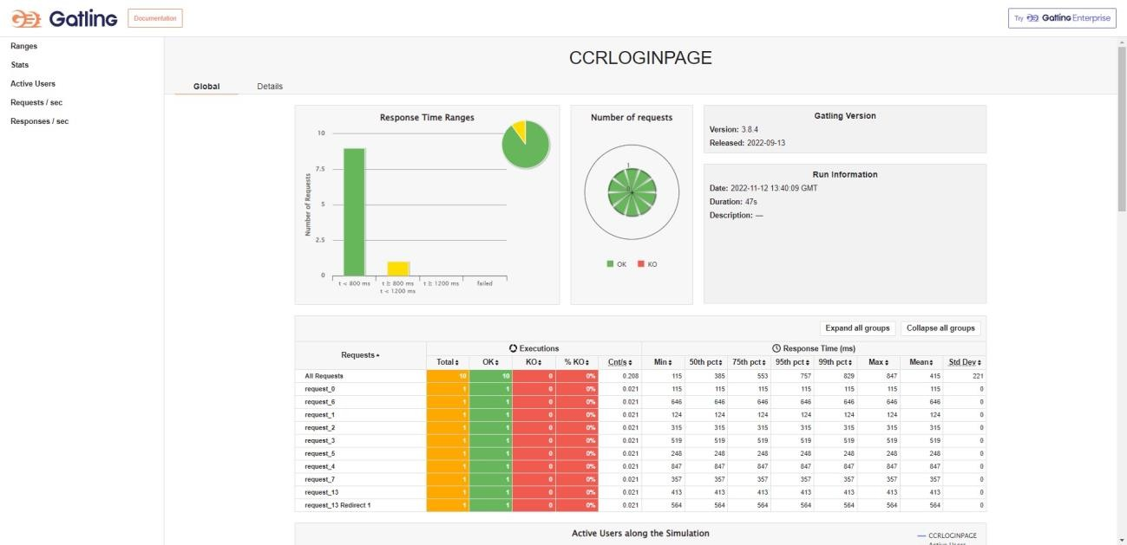

# output screen :

*Home screen*

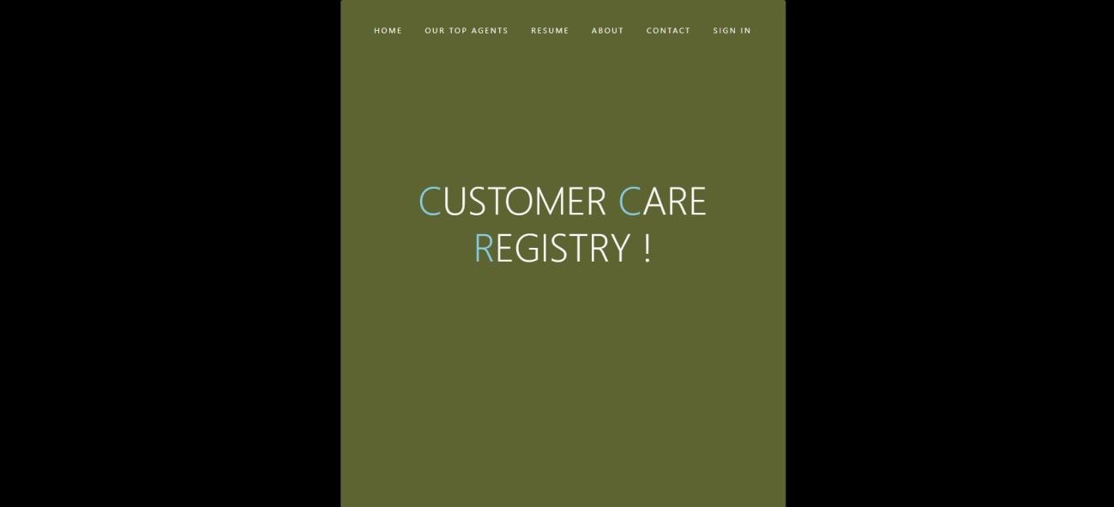

*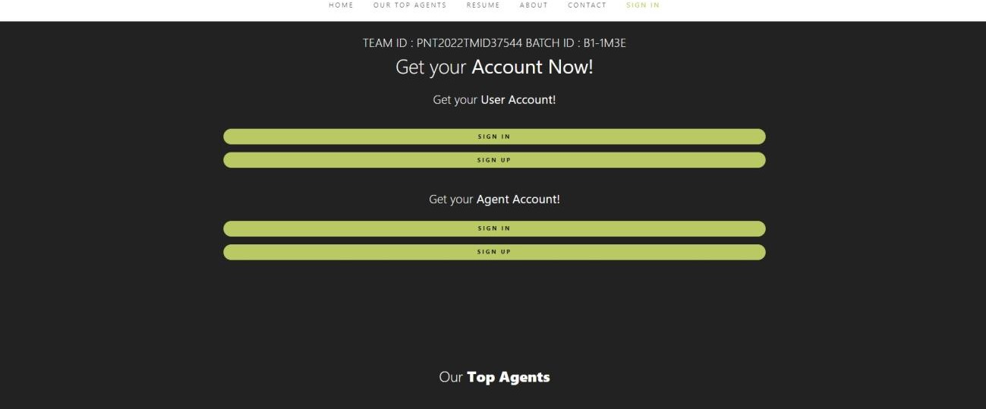User And Agent (Sign in or Sign up) page*

*Our Top Agents*

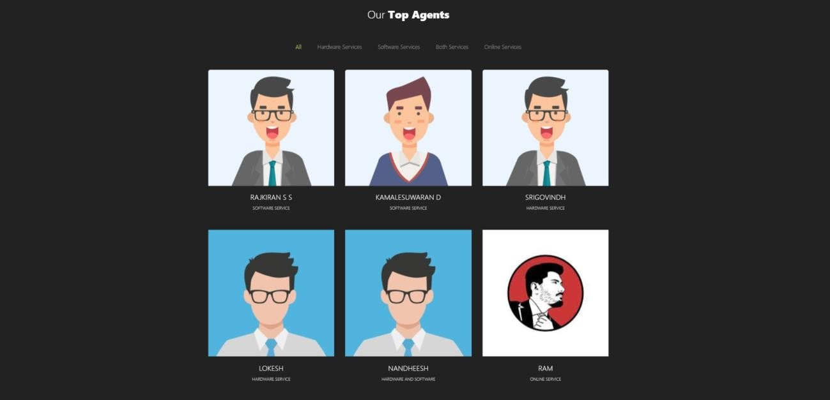

#### Our Feature

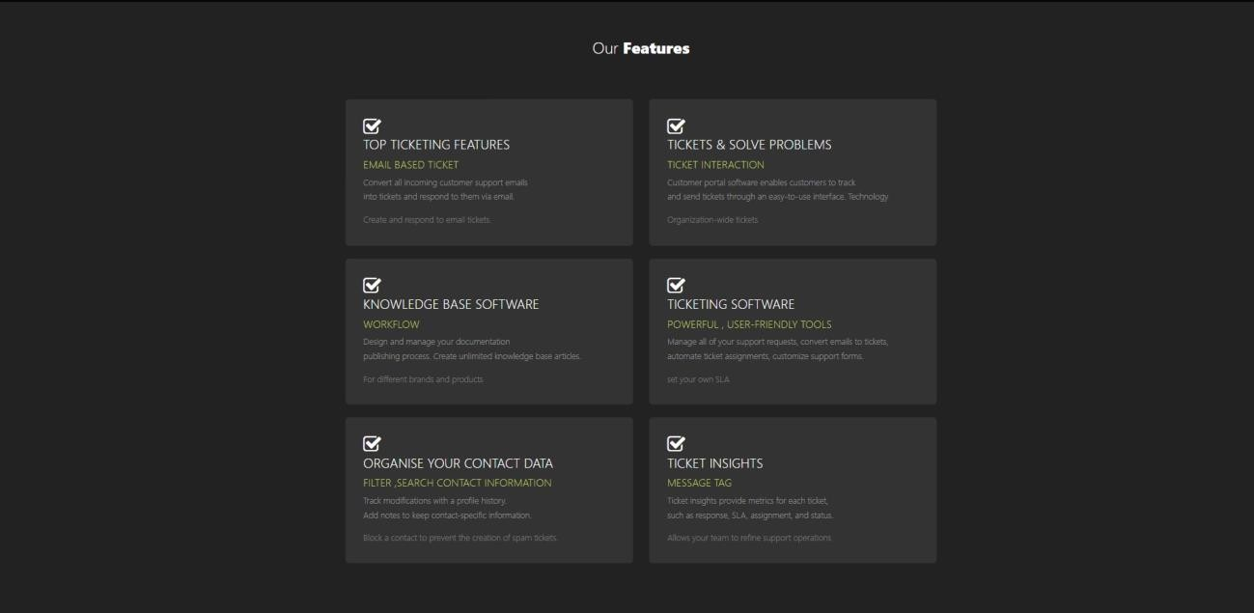

*My Services*

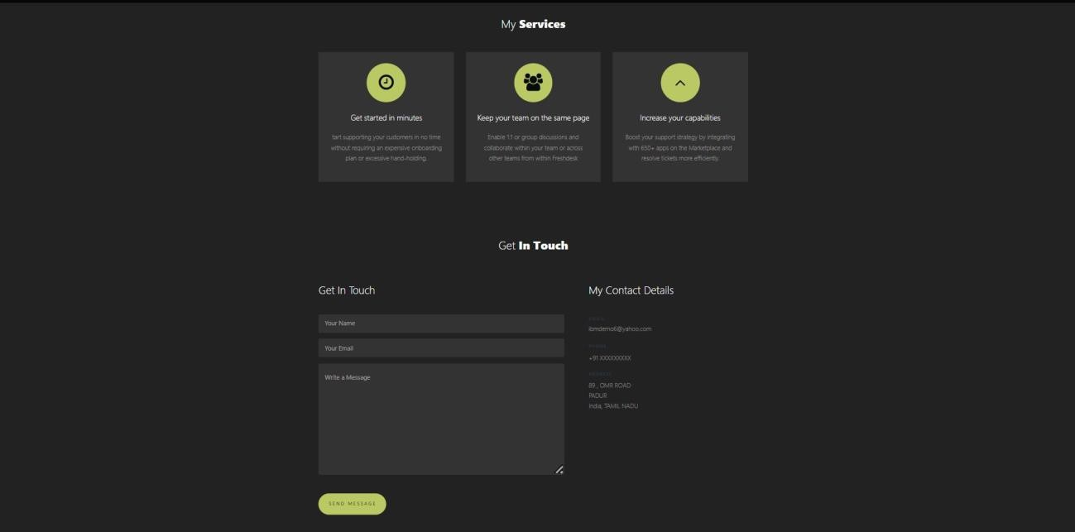

*Customer Register*

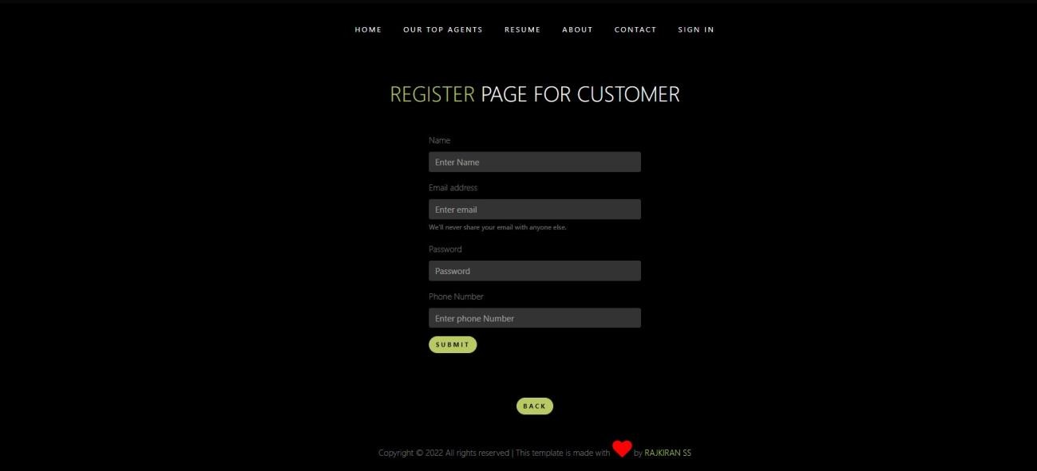

*Customer LOGIN*

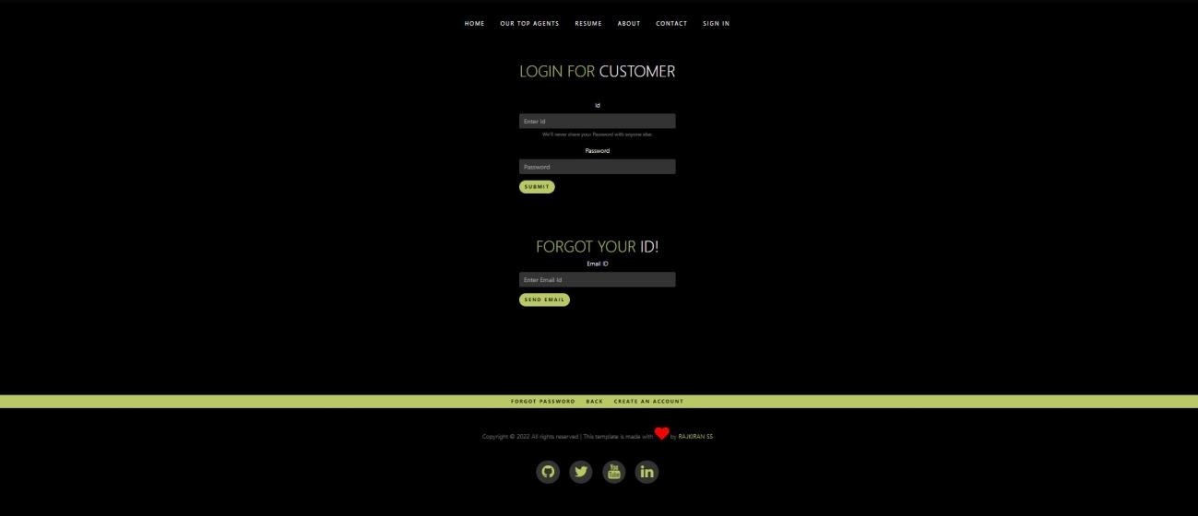

* + 1. *ADVANTAGES & DISADVANTAGES*

***Advantages :***

###### Customer loyalty

Loyal customers have many benefits for businesses. 91% of customers say a positive customer service experience makes them more likely to make a further purchase (source: [Salesforce Research)](https://c1.sfdcstatic.com/content/dam/web/en_us/www/documents/research/salesforce-state-of-the-connected-customer-4th-ed.pdf). Also, investing in new customers is five times more expensive than retaining existing ones (source: [Invesp](https://www.invespcro.com/blog/customer-acquisition-retention/)). Creating loyal customers through good customer service can therefore provide businesses with lucrative long-term relationships.

###### Increase profits

These long-term customer relationships established through customer service can help businesses become more profitable. Businesses can grow revenues between 4% and 8% above their market when they prioritise better customer service experiences (source: [Bain & Company](http://www.bain.com/infographics/five-disciplines/)). Creating a better customer service experience than those offered by competitors can help businesses to standout in their market place, and in turn make more sales.

###### Customer recommendations

Providing good customer service can create satisfied customers, who are then more likely to recommend the business to others. 94% of customers will

recommend a company whose service they rate as “very good” (source: [Qualtrics](https://success.qualtrics.com/rs/542-FMF-412/images/ROI%20of%20customer%20experience%202020.pdf) [XM Institute)](https://success.qualtrics.com/rs/542-FMF-412/images/ROI%20of%20customer%20experience%202020.pdf). This is useful, as 90% of customers are influenced by positive reviews when buying a product (source: [Zendesk)](https://d16cvnquvjw7pr.cloudfront.net/resources/whitepapers/Zendesk_WP_Customer_Service_and_Business_Results.pdf). Customers recommending a company through word of mouth or online reviews can improve the credibility of the business.

###### Increase conversion

Good customer service can help businesses turn leads into sales. 78% of customers say they have backed out of a purchase due to a poor customer experience (source: [Glance)](http://ww2.glance.net/wp-content/uploads/2015/07/Counting-the-customer_-Glance_eBook-4.pdf). It is therefore safe to assume that providing good customer service will help to increase customer confidence and in turn increase conversion.

###### Improve public image

Customer service can help businesses to improve the public perception of the brand, which can then provide protection if there is a slip up. 78% of customers will forgive a company for a mistake after receiving excellent service (source: [Salesforce Research](https://c1.sfdcstatic.com/content/dam/web/en_us/www/documents/research/salesforce-state-of-the-connected-customer-4th-ed.pdf)). Meanwhile, almost 90% of customers report trusting a company whose service they rate as “very good.” On the other hand, only 16% of those who give a “very poor” rating trust companies to the same degree(source: [Qualtrics XM Institute)](https://success.qualtrics.com/rs/542-FMF-412/images/ROI%20of%20customer%20experience%202020.pdf). Creating positive customer experiences is vital in gaining customer trust and creating a strong public image.

### Disadvantage :

The Consumer Protection Act in India has numerous restrictions and drawbacks, which are listed in this article.

* 1. *Only services for which a particular payment has been made are covered under the consumer protection act. However, it does not protect medical professionals, or hospitals, and covers cases when this act does not apply to free medical care.*
  2. *This act does not apply to mandatory services, such as water supply, that are provided by state agencies.*
  3. *Only two clauses related to the supply of hazardous materials are covered by this act. Consumer redress is not given any power by the consumer protection act.*
  4. *The consumer protection act focuses on the supply of ineffective products, but there are no strict regulations for those who produce it.*
     1. ***CONCLUSION***

###### It is a web-enabled project.

 With this project the details about the product will be given to the customers in detail with in a short span of time.

Queries regarding the product or the services will also be clarified.



It provides more knowledge about the various technologies

## *FUTURE SCOPE*

## *APPENDIX*

***SOURCE CODE :***

##### Templates:

***github id : https://github.com/IBM-EPBL/SI-GuidedProject-53983-1663928165***

***video-link :***

***link :***